DAT 520 Problem Set 1

Michael Surdek

Southern New Hampshire University

**Homework Problems:** Now, calculate these matrices using R. Copy the R session showing your commands and results and paste into a Word document to submit to the classroom. All problems below can be completed using the information found in the prior sections of this document. If you have any questions, please post to the General Questions area of your classroom and your instructor or other students will be able to assist you. Feel free to extend your learning and practice additional matrix commands. Post any questions you have.

Hint: Remember to create the datasets as your first step and then perform the math operation.

1)

Two into two matrix with the numbers one, two, three, and four multiplied by two into two matrix with the numbers five, six, seven, and eight.

mat1.a%*%mat1.b

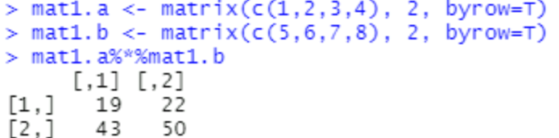

2)

Two into two matrix with the numbers point five, point five, point two five, and point seven five multiplied by two into two matrix point three three, point six seven, point six seven, and point three three.

mat2.a%*%mat2.b

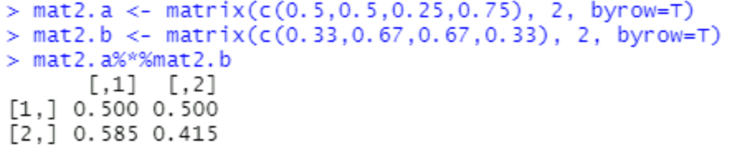

3)

Two into two matrix with the numbers point five, point five, point two five, and point seven five with the whole matrix squared

mat2.a%^%2

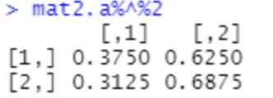

4)

Two into two matrix with the numbers point five, point five, point two five, and point seven five with the whole matrix cubed

mat2.a%^%3

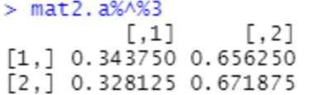

5)

Two into two matrix with the numbers point one five, point eight five, point zero zero one, and point nine nine nine to the power four plus two into two matrix with the numbers point zero two, point nine eight, point one nine, and point eight one to the power of seven. 

install.packages("expm")

library(expm)

mat5.a

mat5.b = matrix (c(.02,.98,.19,.81), 2 , byrow =T )

mat5.b

mat5.a = matrix (c(.15,.85,.001,.999), 2 , byrow =T )

(mat5.a%^%4) + (mat5.b%^%7)

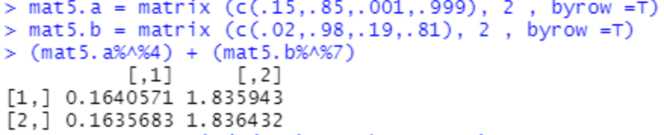

6)

One into two matrix with the numbers one and two multiplied by two into two matrix with the numbers five, six, seven, and eight.

mat6.a%*%mat1.b

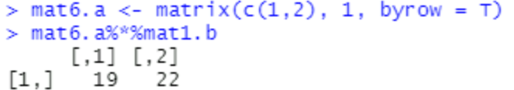

7)

One into two matrix with the numbers point zero eight and point zero nine two multiplied by two into two matrix with the numbers point three seven five, point six two five, point three nine nine, and point six zero one.

mat7.a%*%mat7.b

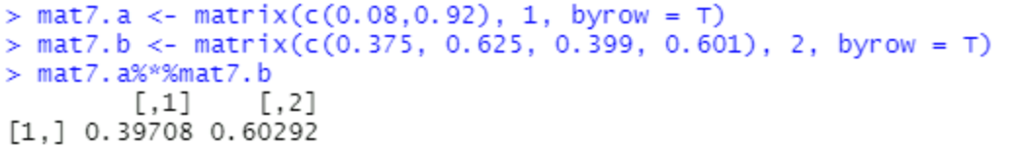

8) Remember to use the correct order of operations by careful use of parentheses:

One into two matrix with the numbers point zero eight and point zero nine two multiplied by two into two matrix with the numbers point three seven five, point six two five, point three nine nine, and point six zero one.

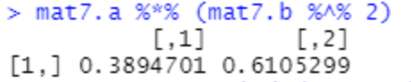

9)

One into one matrix with the numbers point five and point five multiplied by two into two matrix with the numbers point five, point five, point five, and point five, with the matrix whole squared.

(mat9.a)%*%(mat9.b%^%2)

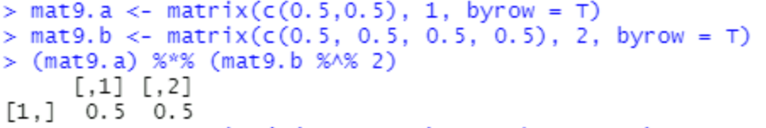

10)

One into one matrix with the numbers point zero one four and point nine eight six multiplied by a two into two matrix with the numbers point one three five, point eight six five, point five zero one, and point four nine nine.

install.packages("expm")

library(expm)

mat10.a = matrix (c(.014,.986), 1 , byrow =T )

mat10.a

mat10.b = matrix (c(.135,.865,.501,.499), 2 , byrow =T )

(mat10.a)%*%(mat10.b%^%7)

